<https://gateoverflow.in/376421>

[Algorithms: GO Classes Test Series 2023 | Data Structures | Test 5 | Question: 2 (gateoverflow.in)](https://gateoverflow.in/376419/go-classes-test-series-2023-data-structures-test-5-question)

<https://gateoverflow.in/376413>

[Algorithms: GO Classes Test Series 2023 | Data Structures | Test 5 | Question: 6 (gateoverflow.in)](https://gateoverflow.in/376411/go-classes-test-series-2023-data-structures-test-5-question)

[Algorithms: GO Classes Test Series 2023 | Data Structures | Test 5 | Question: 7 (gateoverflow.in)](https://gateoverflow.in/376409/go-classes-test-series-2023-data-structures-test-5-question)

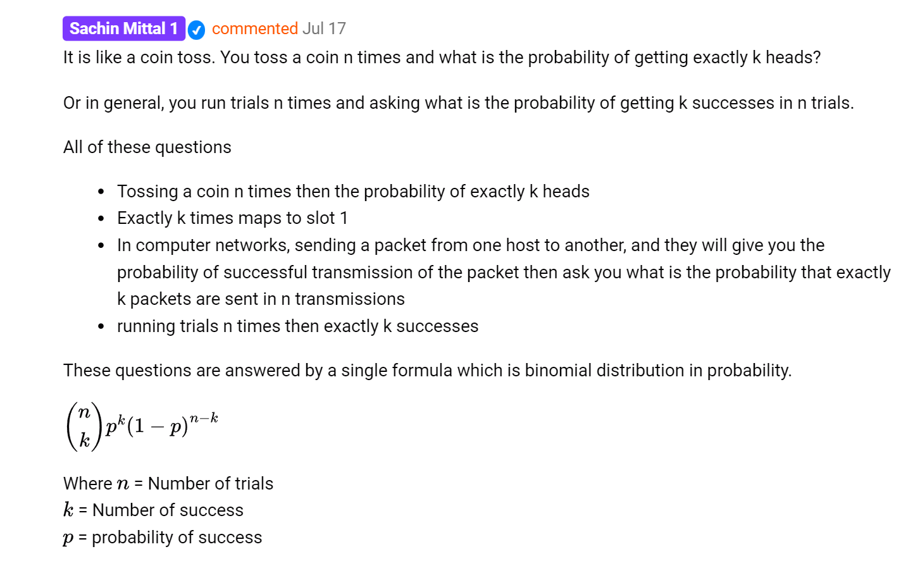

[Algorithms: GO Classes Test Series 2023 | Data Structures | Test 5 | Question: 9 (gateoverflow.in)](https://gateoverflow.in/376406/go-classes-test-series-2023-data-structures-test-5-question)

<https://gateoverflow.in/376400/go-classes-test-series-2023-data-structures-test-question-13?show=388281#c388281>

[Algorithms: GO Classes Test Series 2023 | Data Structures | Test 5 | Question: 14 (gateoverflow.in)](https://gateoverflow.in/376398/go-classes-test-series-2023-data-structures-test-question-14)

<https://gateoverflow.in/376388>

<https://gateoverflow.in/376386>